Study Guide for NIBIN Casework Training

Module 1 – General Firearms and Ammunition Overview and Safety

- List 10 key rules of safe firearm handling, to include the three common fundamental safety rules.

- Identify and label ammunition component diagrams using correct nomenclature.

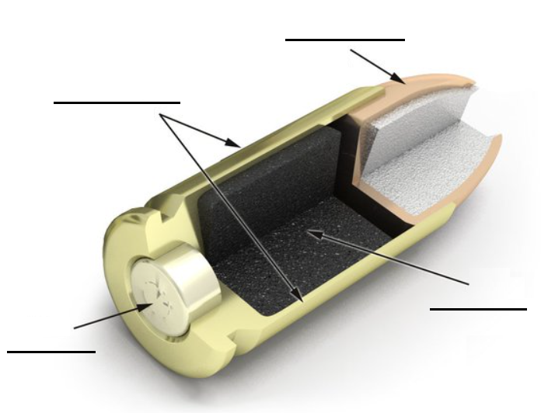

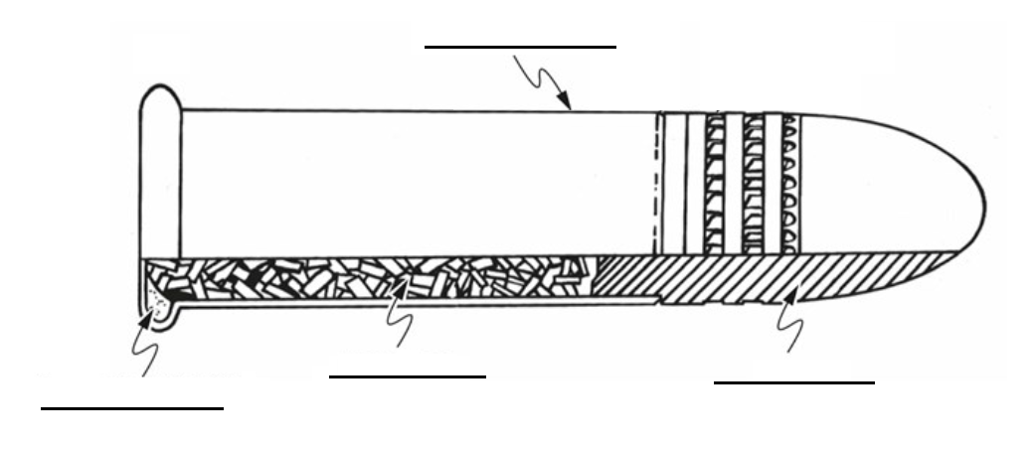

- Study questions

  - Define Accidental Discharge.

  - Define Unintentional Discharge.

  - What are some common causes of an obstructed barrel and what are the potential consequences of firing a gun with an obstructed barrel?

  - What are some of the sources of lead expelled from a firearm during firing and what ammunition components may have lead residue on them? What are some symptoms of lead poisoning and how can you reduce the risks of lead exposure?

Module 2 – Mechanics (only required to perform NIBIN cases involving firearms)

- Definitions

  - Automatic
  - Bolt
  - Semiautomatic
  - Breech/Breechface
  - Caliber
  - Carbine
  - Chamber
  - Cylinder
  - Pistol
  - Revolver
  - Rifle
  - Shotgun
  - Machine Gun
  - Sub-Machine Gun
  - Single Action
  - Double Action
  - Hybrid Action
  - Ejector
  - Extractor
  - Magazine
  - Clip
  - Firing Pin
  - Striker
  - Safety Mechanism
  - Manually Operated Safety
  - Automatic Safety
  - Passive Safety
  - Cock
  - Out-of-Battery
  - Function Testing
  - Malfunction
  - Misfire
  - Squib Load
  - Slam Fire

- Identify and label firearm component diagrams using correct nomenclature.

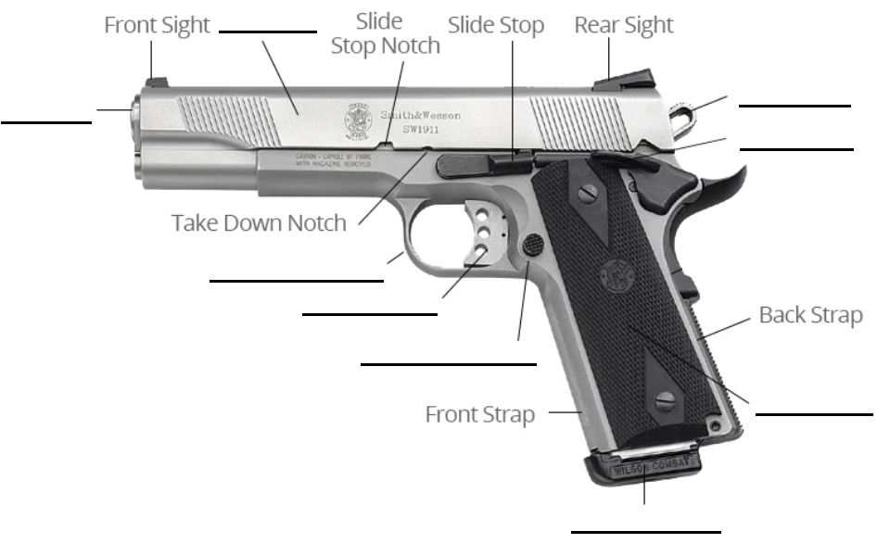

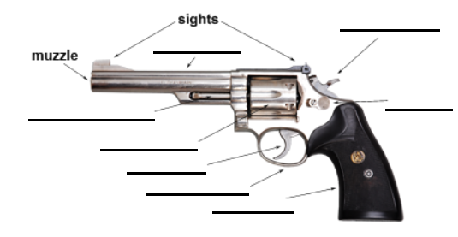

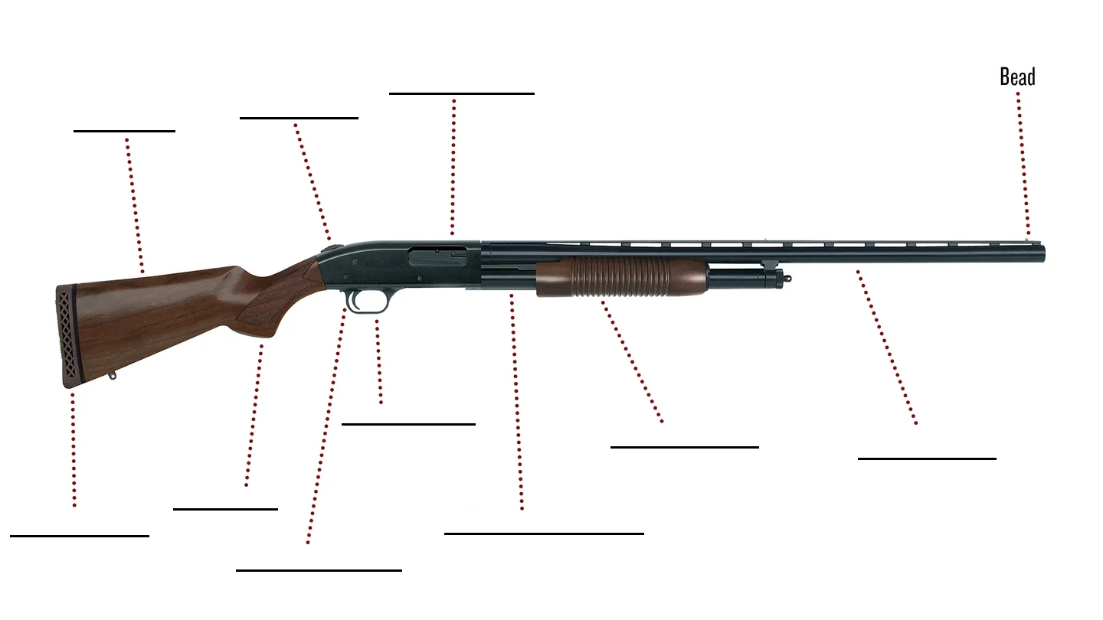

- List and describe the cycle-of-fire steps involved in discharging a firearm.

- Mechanics Exercises

  - Revolvers
    - Single Action
      - New Model Ruger
      - North American Arms Mini Revolver
    - Double Action
      - Smith & Wesson Model 10
      - R.G. Industries (any model)
      - Iver Johnson “Owl Head”

  - Semiautomatic Pistols
    - Single Action
      - Government Model Colt 45
      - Lorcin caliber 25 Auto
      - Hi-Point (any model)
    - Double Action
      - Beretta 92F
      - Smith and Wesson 5904
      - Ruger P Series
    - Hybrid Action
      - Glock 17

  - Rifles and Shotguns
    - Single Shot
      - H&R Topper Model 58
    - Lever Action
      - Winchester Model 94
    - Pump/Slide Action
      - Remington 870
    - Bolt Action
      - Remington Model 700
    - Semiautomatic
      - Remington Model 1100
      - AR-15
      - Hi-Point Carbine

  - Automatic Firearms
    - Automatic
      - Thompson caliber 45 Auto
      - Uzi caliber 9mm
      - AK-47

Module 3 – Microscopy

- Definitions

  - Microscope
  - Magnification (include formula for determining power)
  - Compound microscope
  - Objectives
  - Ocular/Eyepiece
  - Resolution
  - Numerical aperture (include formula)
  - Depth of field (include formula)
  - Stereomicroscope
  - Comparison microscope

- Study Question

  - How does a stereomicroscope achieve a 3-D appearance of specimens?

Module 4 – Fired Ammunition Class Characteristics

- Definitions

  - Class characteristics
  - Subclass characteristics
  - Caliber (as it pertains to class characteristics)
  - Bullet
  - Cartridge
  - ACP
  - Ammunition
  - Parabellum
  - Chamber marks
  - Breechface impression
  - Firing pin impression
  - Firing pin aperture
  - Firing pin aperture shear mark
  - Ejector mark
  - Extractor mark

- Study Questions

  - What class characteristics are present on cartridge cases fired in semiautomatics firearms that are not present on cartridge cases fired in revolvers?

  - What are the various types of chamber marks?

  - Other than chamber marks, what other marks appear on a fired cartridge case? Describe the location and shape of these markings.

  - Which class characteristics can be used to group a set of fired cartridge cases for NIBIN casework?

  - Of the following calibers, list their metric/english equivalents:

- 25 Auto
- 7.62x39mm
- 300 Blackout
- 223 Remington / 5.56 NATO
- 32 Auto
- 9mm Luger
- 380 Auto
- 357 Sig
- 40 S&W
- 10mm
- 44 Pistol
- 45 ACP

- Identify and label fired cartridge case diagrams using correct nomenclature.

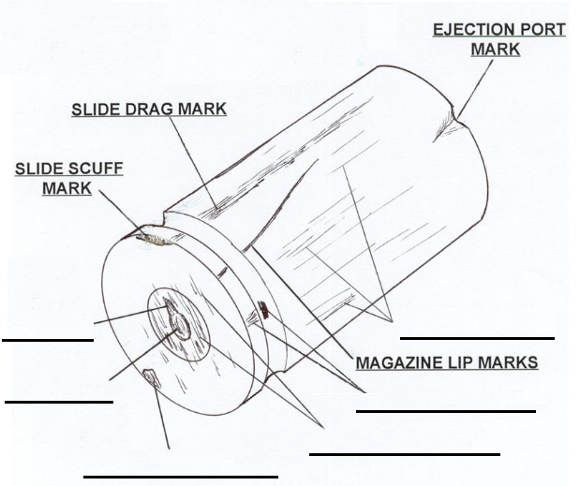

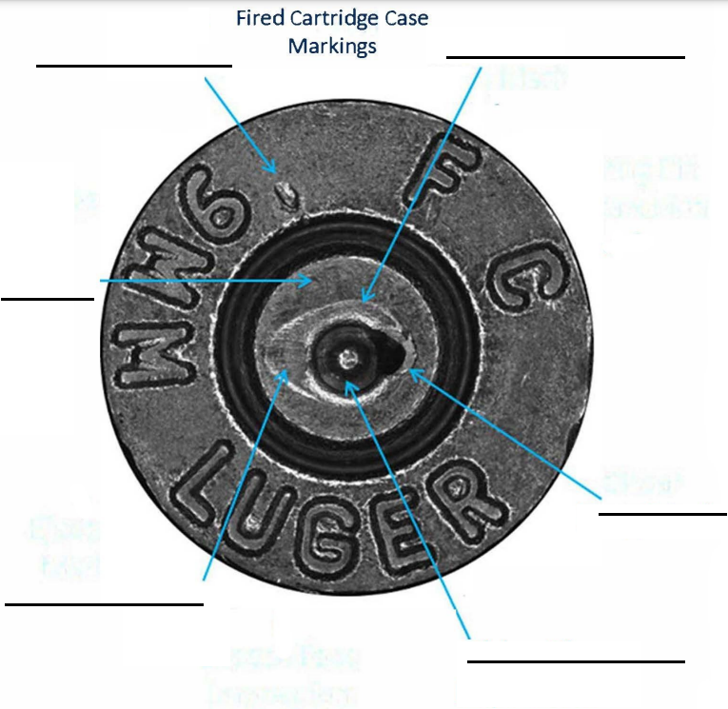

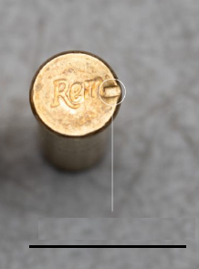

Module 5 – IBIS Entry
None
Module 6 – Presentation of Evidence in Court
- Definitions

        - District Attorney
        - Defense Attorney
        - Pre-trial Meeting
        - Discovery Request
        - Deposition
        - Preliminary Hearing
        - Sequestering of Witnesses
        - Expert Witness
        - Stipulate
        - Voir Dire
        - Daubert Criteria
        - Rule 702
        - Motion to Suppress
        - Direct Examination
        - Re-Direct Examination
        - Cross Examination
        - Re-Cross Examination
        - Sustained Objection
        - Overruled Objection
  - Leading Questions
  - Plea Bargain
  - Mistrial

- Prepare responses to qualifying questions. It should be noted that although it is not possible to provide a list of all the questions that might be posed in a courtroom, the following will provide some insight into the type or questioning an expert witness may experience:

  - Please state your full name and spell it for the record.
  - Where do you work and what is your position?
  - How long have you been employed with the State Crime Laboratory?
  - What are your duties?
  - What type of education, training, and experience do you have that qualifies to work NIBIN cases?
  - How many NIBIN cases have you worked?.
  - Have you testified before regarding NIBIN cases?
  - How many times?
  - What is IBIS?
  - What is NIBIN?
  - What is BrassTRAX?
  - What type of evidence is entered into NIBIN?
  - What is a correlation list?
  - What are the results from entering evidence into NIBIN?

